AT3 Part 5

30003673

[School]

[Course title]

Table of Contents

Describe how you are going to test your application (list all test scenarios) 2

Provide results for each test from the previous question 2

Describe what you need to do to the PHP environment to prevent error messages displaying to the public 6

Describe changes you need to make to your PHP program to minimize potential database attacks. 6

All fields in your database must have appropriately-defined data types. Explain how your application handles data entry errors when one of the constraints is violated e.g. a digits are entered into a first name field. 7

Explain how your application behaves when it cannot connect to the database (note: your application MUST behave gracefully in such situations). 7

Provide an explanation of alternative strategies for managing disconnected data (offline connectivity). 7

# Describe how you are going to test your application (list all test scenarios)

List suppliers

Add Supplier

List products

List products by category

List product by supplier

List invoices

List customers

Add customer

List employees

List invoices by employee

# Provide results for each test from the previous question

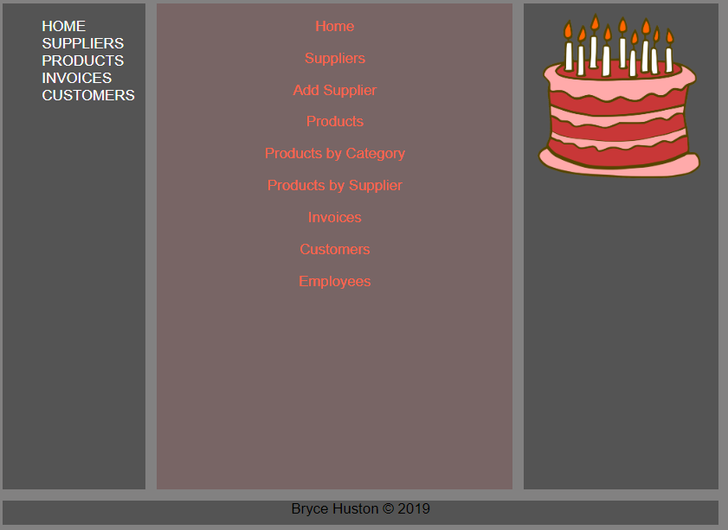

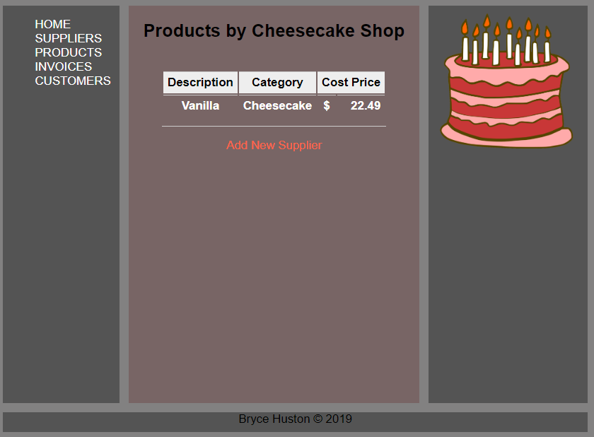

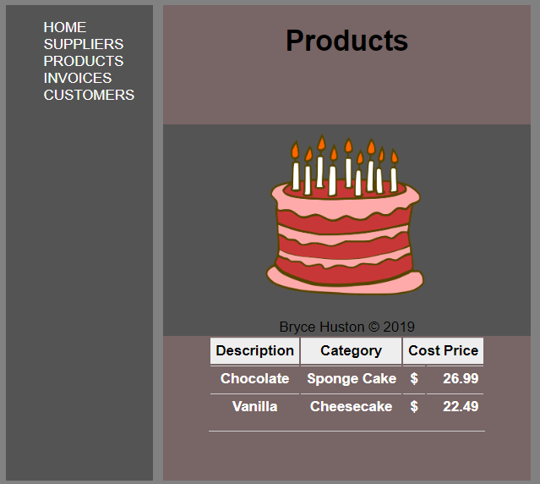

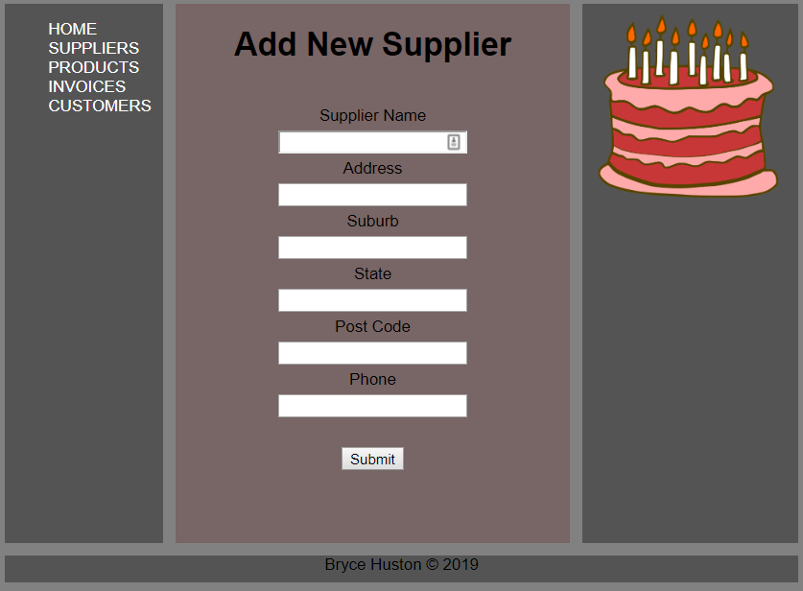

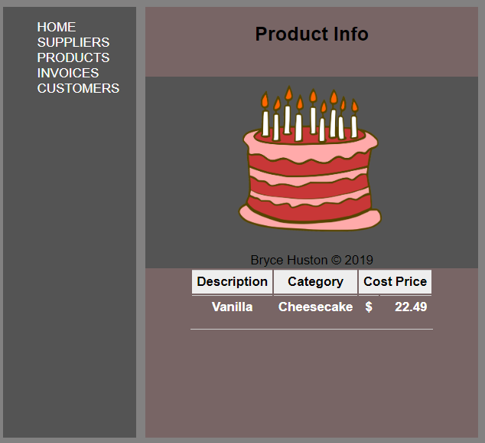

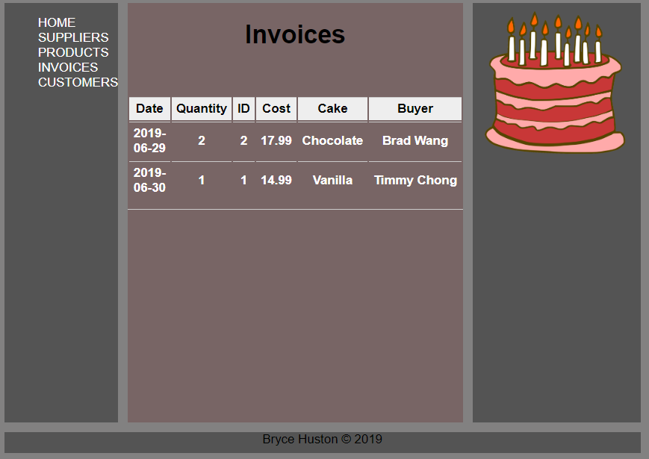

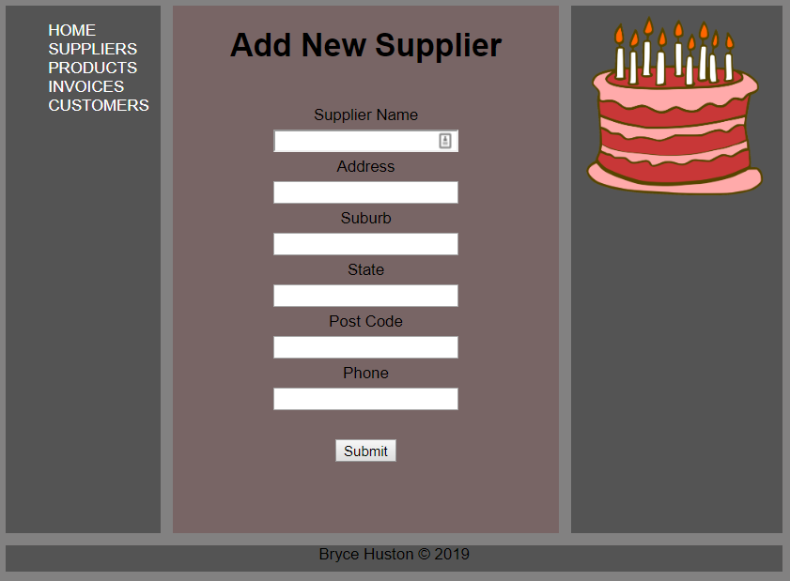

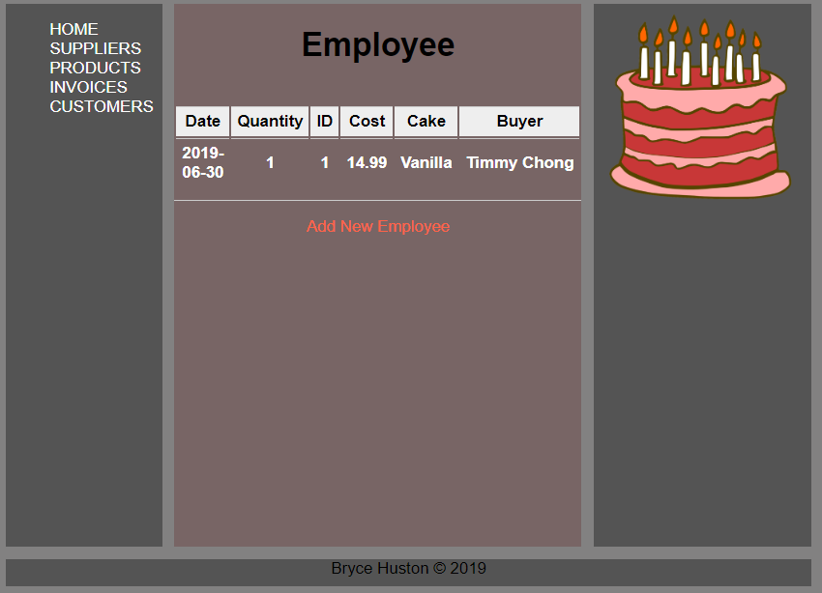

# Describe what you need to do to the PHP environment to prevent error messages displaying to the public

In php.ini, make `display_errors` to Off to disable the public showing of errors. They still get logged.

# Describe changes you need to make to your PHP program to minimize potential database attacks.

Setup a firewall to stop SQL injections straight into the database. This can be done by making the database only accept localhost connections on the 3306 port.

# All fields in your database must have appropriately-defined data types. Explain how your application handles data entry errors when one of the constraints is violated e.g. a digits are entered into a first name field.

When the wrong data is inserted, it will not add the data but show the user an error message displaying why the data was not added.

# Explain how your application behaves when it cannot connect to the database (note: your application MUST behave gracefully in such situations).

It will fail to show data and display a blank page.

# Provide an explanation of alternative strategies for managing disconnected data (offline connectivity).

You could cache certain data to be viewed or just redirect users to a help page that will show how to get the database working again if possible.